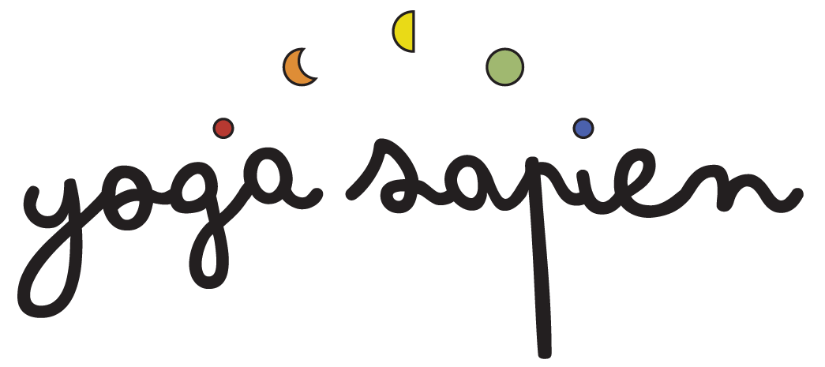

Yoga Sapien
Booking Form

24th – 27th April 2026

Name:
Email address:
Mobile No: D.O.B.
Emergency Contact:
Name: Relationship to you:
Mobile No:

How Did You Hear About Us?
Been before ◻ Instagram ◻ Facebook ◻
Recommendation ◻ Google ◻ Other ◻ ________________

Room preference: (please bear in mind, rooms are limited, and we act on a first come, first served basis. However, we will do our best to accommodate your preference)

PLEASE HIGHLIGHT YOUR PREFERENCE:
PLAS:
1 double room - £695
2 single rooms - £680
4 twin rooms - £610

ERYR:
3 single courtyard rooms - £645

A non-refundable deposit of £120, together with this completed booking form is required to secure your place. The balance will be due 1 month prior to the retreat on Friday 27th March 2026 (ref. terms & conditions)

Deposit and balance payments may be made BACs bank transfer to:

Account Name: Miss J H Wallace
Account No: 31132844
Sort Code: 09-01-29
Please use your name and the word ‘TRIGONOS’ as reference.

Medical Information
Please read carefully and answer each question, deleting either YES or NO
1) Do you have a heart condition and whereby you should only do physical activity recommended by a doctor?
YES/NO

2) Are you taking any prescribed medication for your blood pressure or
heart condition?
YES/NO

3) Do you lose your balance because of dizziness or do you ever lose consciousness?
YES/NO

YES/NO
4) Do you have a bone or joint problem (e.g. back, knee, or hip) that could be made worse by a change in your physical activity?

If you have highlighted ‘YES’ to any of the above, or would like to tell us about anything else, please provide further details here:

I have read, understood and completed the above form to the best of my knowledge. I confirm that I am voluntarily engaging in an acceptable level of activity and my participation involves a risk of injury.

I have read the terms and conditions (see website).

Signature: Print name:

Date:

THANK YOU so much and we look forward to seeing you!
Please return the form to jacq@yogasapien.co.uk

