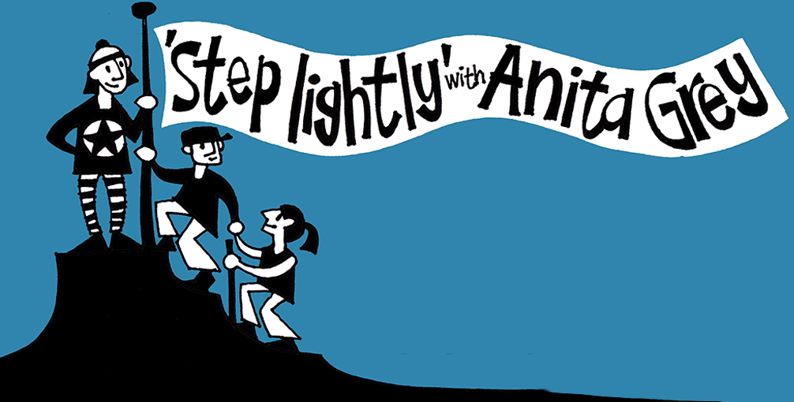
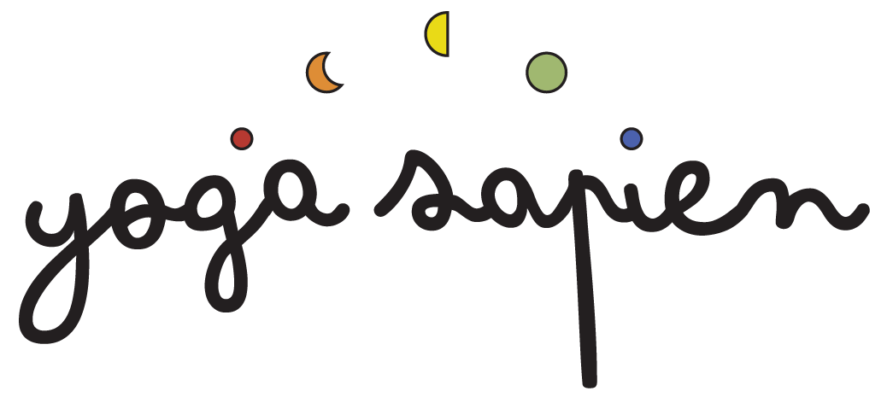
Yoga Sapien
Booking Form for Brathay Retreat
October 2022

Name:
Email address:
Mobile No: D.O.B.

Emergency Contact:
Name: Relationship to you:
Mobile No:

How did you hear about us?
Been before ◻ Instagram ◻ Facebook ◻
Recommendation ◻ Google ◻ Other ◻ ________________

Room preference: (please bear in mind, rooms are limited, and we act on a first come, first served basis. However, we will do our best to accommodate your preference)

PLEASE HIGHLIGHT YOUR PREFERENCE:
Single Occupancy:
- Single (Loughrigg room) £525
- Twin/double room (Helvellyn room) £575
Sharing a Room - (Please note - this is a women only retreat, therefore if you are single and would like to share a room, be assured you will only be sharing with another woman)

- Superior twin/double room (Scafell Lodge) £545

A non-refundable deposit of £120, together with this completed booking form is required to secure your place. The balance will be due on Friday 2nd September 2022 (ref. terms & conditions)

Deposit and balance payments may be made BACs bank transfer to:

Account Name: Miss J H Wallace
Account No: 31132844
Sort Code: 09-01-29
Please use your name and the word ‘BRATHAY’ as reference.

Medical Information
Please read carefully and answer each question, highlighting either YES or NO
1) Do you have a heart condition and whereby you should only do physical activity recommended by a doctor?
NO
YES

2) Are you taking any prescribed medication for your blood pressure or
heart condition?
YES
NO

3) Do you lose your balance because of dizziness or do you ever lose consciousness?
YES
NO

4) Do you have a bone or joint problem (e.g. back, knee, or hip) that could be made worse by a change in your physical activity?
NO
YES

If you have highlighted ‘YES’ to any of the above, or would like to tell us about anything else, please provide further details here:

I have read, understood, and completed the above form to the best of my knowledge. I confirm that I am voluntarily engaging in an acceptable level of activity and my participation involves a risk of injury. Yes / No - delete as appropriate

I have read the terms and conditions (see here). Yes / No - delete as appropriate

Signature: _______________________ Print name: ____________________________

Date: _______________

THANK YOU so much and we look forward to seeing you!
Please return the form to jacq@yogasapien.co.uk

